|  |
| --- |
| User’s Manual |

|  |
| --- |
| Mexilab Application |

|  |
| --- |
| Project Iot |

***Contents***

1. Login
   1. Administrator
   2. User
2. Spaces
   1. Stage
   2. Floor
   3. Scenarios
   4. Room
3. Devices
   1. Product
   2. Sensor
   3. Location
4. Reports
   1. Consumption

**Login**

As a user, you can enter the system if you have an account. The only way you can have an account is when the administrator registers in the system. Every administrator and user has an encrypted password, so you can not see the password in the database even if you are an administrator.

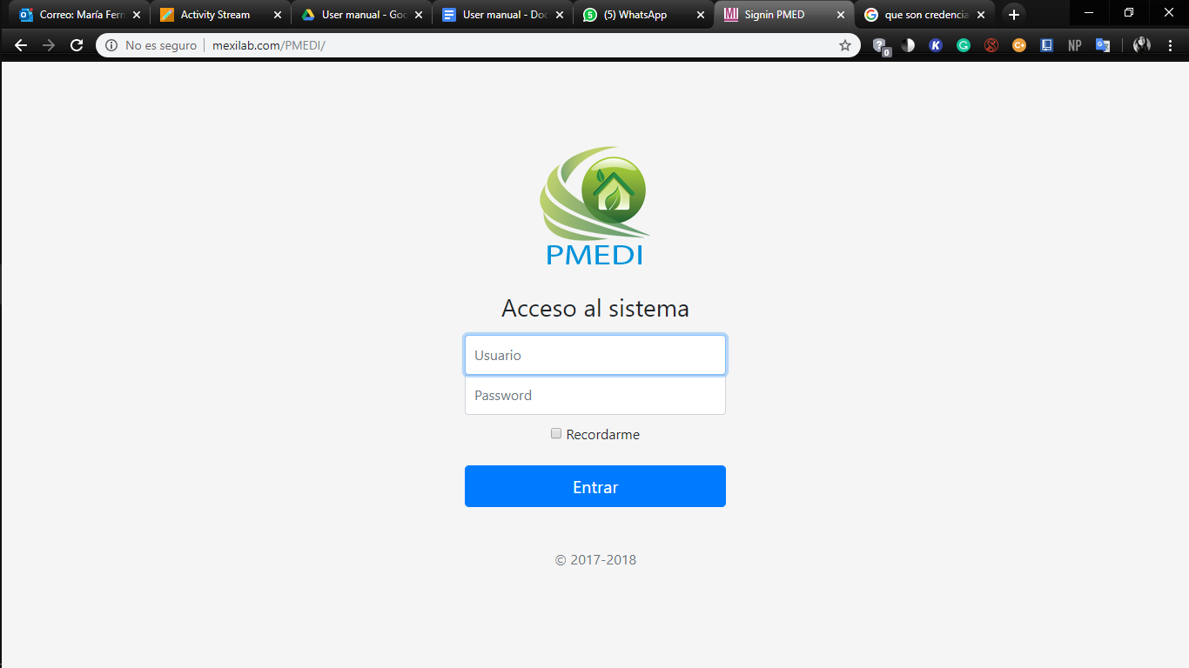

*Image 1 | Login of the system*

***Administrator***

As an administrator, you have to type your id_admin, in this case, your username and your password. You are going to have more functions and privileges inside the system.

***User***

As a user, you have to type your id_admin, in this case, your username and your password. You just can add, edit, delete devices and rooms.

You have to fill the form with the correct data. NOTE: You can change whatever data you want except the username.

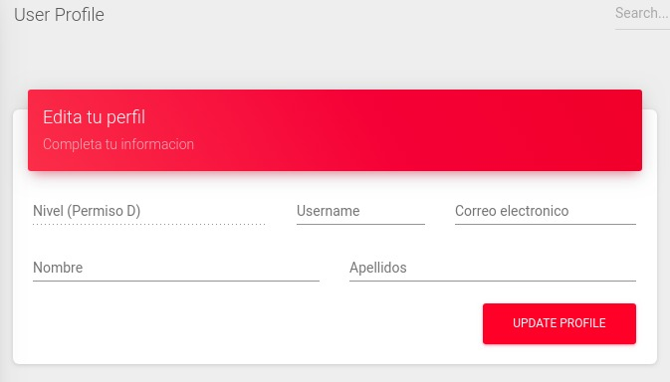

*Image 1 | Form to update user*

**Spaces**

The spaces are all the whole set of rooms and levels inside your house or building.

***Stage***

The stage is the space to keep all your floors and rooms, you can see as a house, office, building or other places. To create you have to set an id and name to identify. You can delete, modify or add more floor/rooms any time. WARNING: If you delete a stage, you are also going to delete all the floor and rooms inside of it.

***Floor***

The floor is the floor level inside your stage you can create how many do you need. Also, you have to set an id for each floor and a name. You can edit or delete any time. WARNING: If you delete a floor, you are also going to delete all the rooms inside of it.

***Scenarios***

The scenarios is a set of categories to classify a room. You can not edit, create or delete scenarios. They are already in the database.

***Room***

The room is the last space you need to create to add devices. It is important to set an id, name, and scenario. You can modify or delete whenever you want.

**Devices**

You can add, edit, modify or delete (WARNING: when you delete a device, just the attribute status is going to change to false or disabled) any device. We have to type of devices: product and sensor. The product is like tv, laptop, microwave, etc. While a sensor is a thing to check the products. Every device has to have a location in a room. 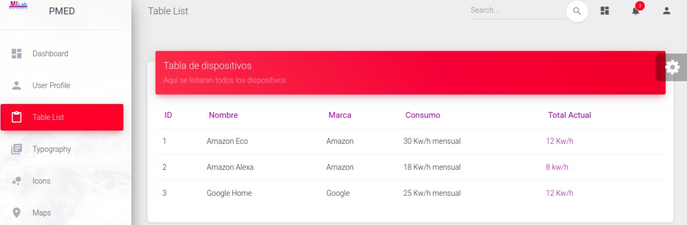

*Image 3 | Show all devices*

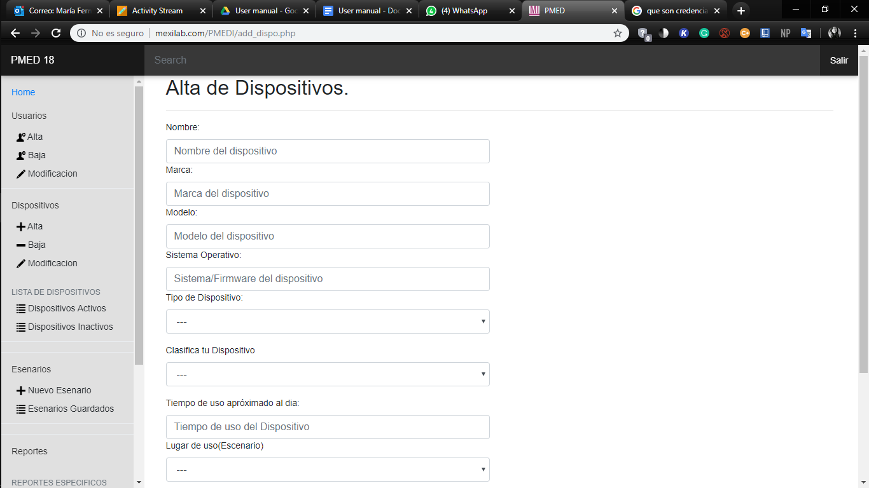

*Image 4 | Form to add device*

**Reports**

Every device has a report showing the consumption of energy on a specific date and time. IMPORTANT: Just the administrator can view the reports.

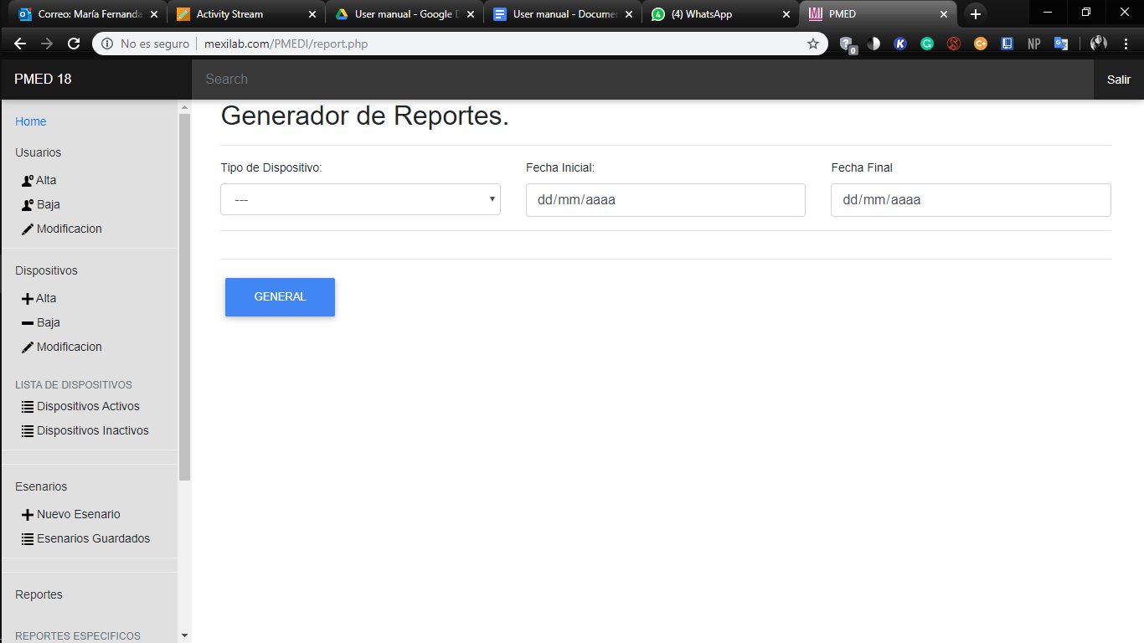

*Image 5 | Form to generate reports*

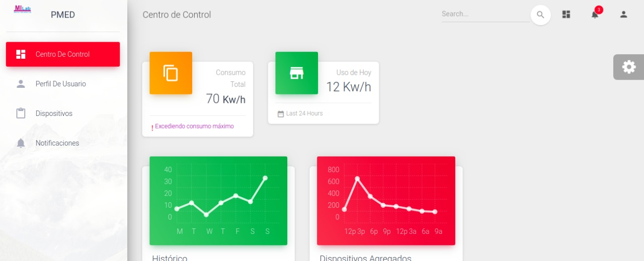

*Image 6 | Control panel*